Monitoring System

Task - Create a Monitoring System to track the server health using node_exporter , Prometheous and grafana.Also integrate alerting system (alert manager + Pagerduty).aslo ensure it support ASG
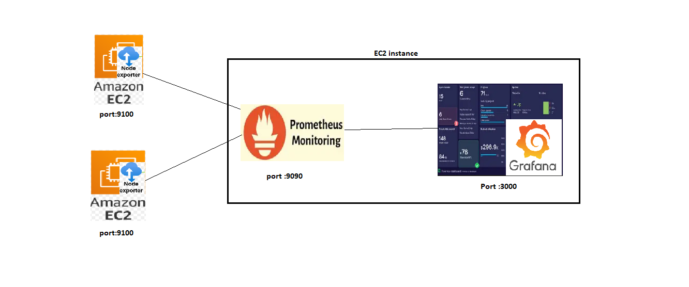
Requirements –
- 3 ec2 instances[ec2-1 (Prometheous +Grafan) ,ec2-2 node_exporter installed]
- node_exporter – its an agent collects the data from the system
- Prometheous – its scrapes (fetch and labels) metrics from the node_exporter
- Grafana - its visualize the data
- SG configuration ( Monitoring – 22,9090,3000,9093 , node_exporter -22,9100)
- Install alert manager +integrate pagerduty

Repo for reference–
itmukesh-16/monitoring-alerting-pagerdutyincident

Implementation:
Application/node_server configutation:
- Create two servers .
- Update package manager
sudo apt update
sudo apt upgrade -y

- Login as non root user -> create non root user ->
sudo useradd --no-create-home --shell /sbin/nologin node_exporter

verify - id node_exporter

- Download Node Exporter
cd /tmp
wget https://github.com/prometheus/node_exporter/releases/download/v1.12.1/node_exporter-1.12.1.linux-amd64.tar.gz
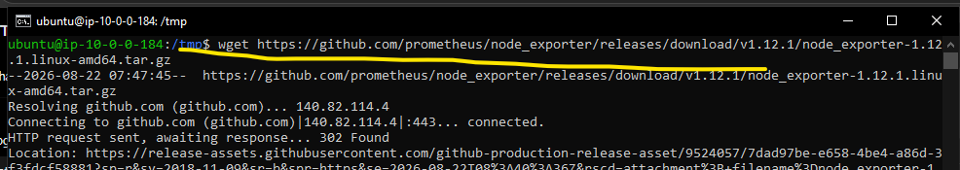

- Extract:
tar -xzf node_exporter-1.12.1.linux-amd64.tar.gz

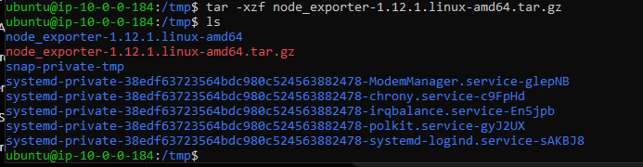

- Now move the node_exporter file to bin folder and change ownership

# sudo mv /tmp/node_exporter-1.12.1.linux-amd64/node_exporter /usr/local/bin/

#sudo chown node_exporter:node_exporter /usr/local/bin/node_exporter

- Create a node_exporter service to autostart on server reboot.

sudo nano /etc/systemd/system/node_exporter.service

[Unit]
Description=Node Exporter
After=network.target

[Service]
User=node_exporter
Group=node_exporter
ExecStart=/usr/local/bin/node_exporter
Restart=always

[Install]
WantedBy=multi-user.target

Save and exit [ CTRL +O enter CTRL +X]

sudo systemctl daemon-reload
sudo systemctl enable --now node_exporter
sudo systemctl status node_exporter

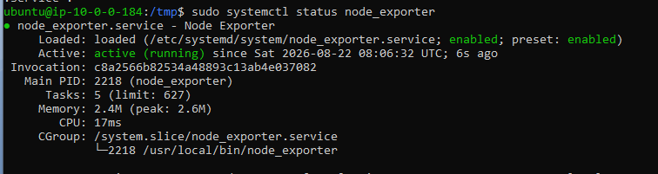

Verify non user - systemctl show node_exporter -p User -p Group
Verify node_exporter –

Run below in same server
curl http://localhost:9100/metrics
or
public ip of node-server:9100

expected o/p
node_cpu_seconds_total
node_memory_MemAvailable_bytes
node_filesystem_avail_bytes

EC2-1: Prometheus configuration:
- Login to prometheous +grafana server .(since we have configured both in same )
cd /tmp

wget https://github.com/prometheus/prometheus/releases/download/v3.5.0/prometheus-3.5.0.linux-amd64.tar.gz

tar -xzf prometheus-3.5.0.linux-amd64.tar.gz

sudo mv prometheus-3.5.0.linux-amd64 /opt/Prometheus

/opt/prometheus/prometheus –version
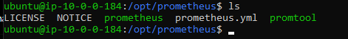

- Create Prometheus non root user

sudo useradd --no-create-home --shell /sbin/nologin Prometheus
sudo mkdir -p /opt/prometheus/data
sudo chown -R prometheus:prometheus /opt/Prometheus

- Prometheous Yaml configuration

Static Metric collection from fixed pvt ip server
sudo nano /opt/prometheus/prometheus.yml

global:
scrape_interval: 15s

scrape_configs:

- job_name: "prometheus"
static_configs:
- targets: ["localhost:9090"]

- job_name: "node-exporter"
static_configs:
- targets: ["<EC2-2-PRIVATE-IP> the server you want to monitor:9100"]

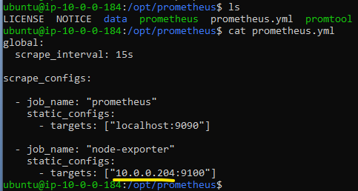

Dynamic Metric collection
Here we have manually added the node-server private ip to the yaml file.
But in dynamic situation like ASG it not possible to add manually and also remove once the server deleted .
To overcome this will need to implement the EC2 service discovery to auto identify the the server having node agent and tell the prometheous to scrape the data.
New EC2 launch → Node Exporter install → add tag (Monitoring=true) → Prometheus discovers it.
Mandatory :
Prometheus EC2 IAM role → ec2:DescribeInstances
Node Exporter SG → TCP 9100 allowed from Prometheus SG and add the tag

- Create a prometheous service

sudo nano /etc/systemd/system/prometheus.service

[Unit]
Description=Prometheus
After=network.target

[Service]
User=prometheus
Group=prometheus
ExecStart=/opt/prometheus/prometheus \
--config.file=/opt/prometheus/prometheus.yml \
--storage.tsdb.path=/opt/prometheus/data

Restart=always
[Install]
WantedBy=multi-user.target

- Check configuration

/opt/prometheus/promtool check config /opt/prometheus/prometheus.yml

sudo systemctl daemon-reload
sudo systemctl enable --now Prometheus
sudo systemctl status prometheus

- test connectivity –

on Prometheus server run
curl http://<EC2-2-PRIVATE-IP > the server you want to monitor :9100/metrics
or
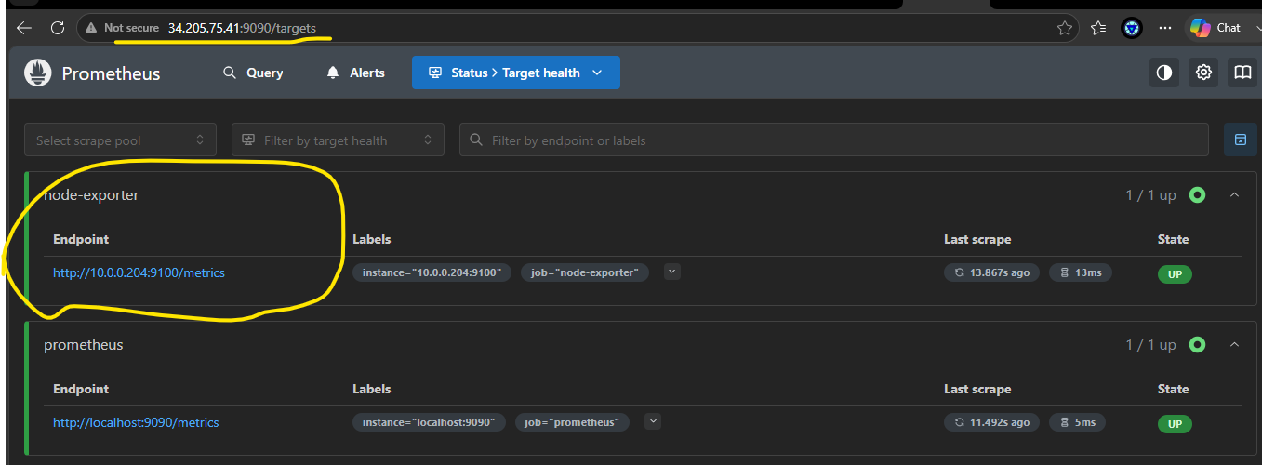

Configure Grafana:

- Create grafana repo

sudo tee /etc/yum.repos.d/grafana.repo <<'EOF'
[grafana]
name=grafana
baseurl=https://rpm.grafana.com
repo_gpgcheck=1
enabled=1
gpgcheck=1
gpgkey=https://rpm.grafana.com/gpg.key
EOF

Or
For ubantu
Add the repository -
echo "deb [signed-by=/etc/apt/keyrings/grafana.gpg] https://apt.grafana.com stable main" | sudo tee /etc/apt/sources.list.d/grafana.list

Package list update in APT -
sudo apt update

installing grafana –
sudo apt install grafana –y

sudo systemctl enable --now grafana-server
sudo systemctl status grafana-server

- Now open and test installation in browser

http:<EC2 public ip >:3000

default user :admin
default password :admin

you can change the admin and password

Now configure Prometheus -> grafana :
Add connection > prometheus
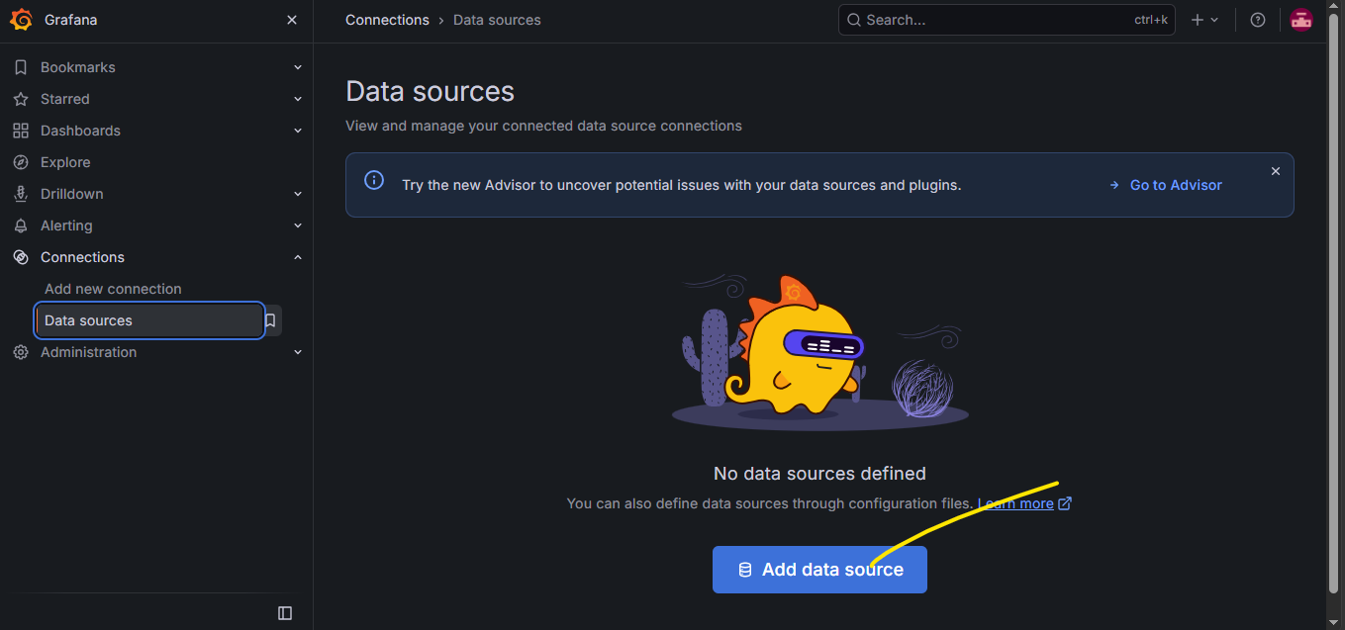

Give source ie Prometheus running server private ip (since both Prometheus and grafana running on the same server we have given localhost or 127.0.0.1)
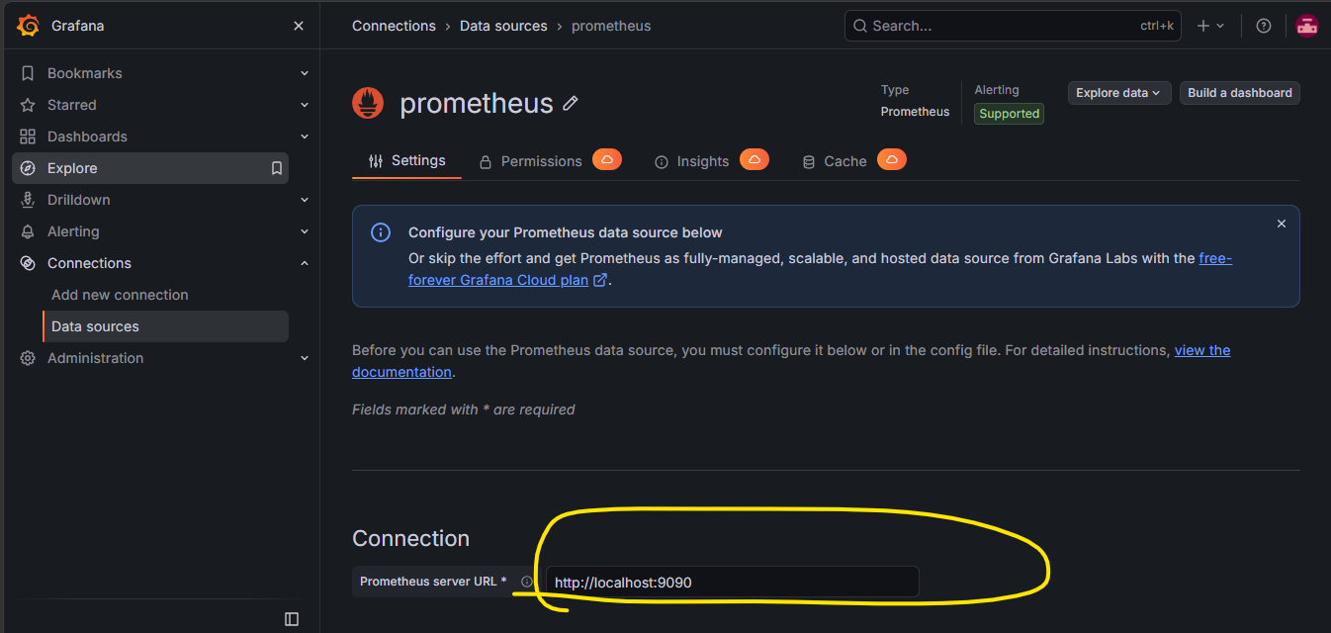

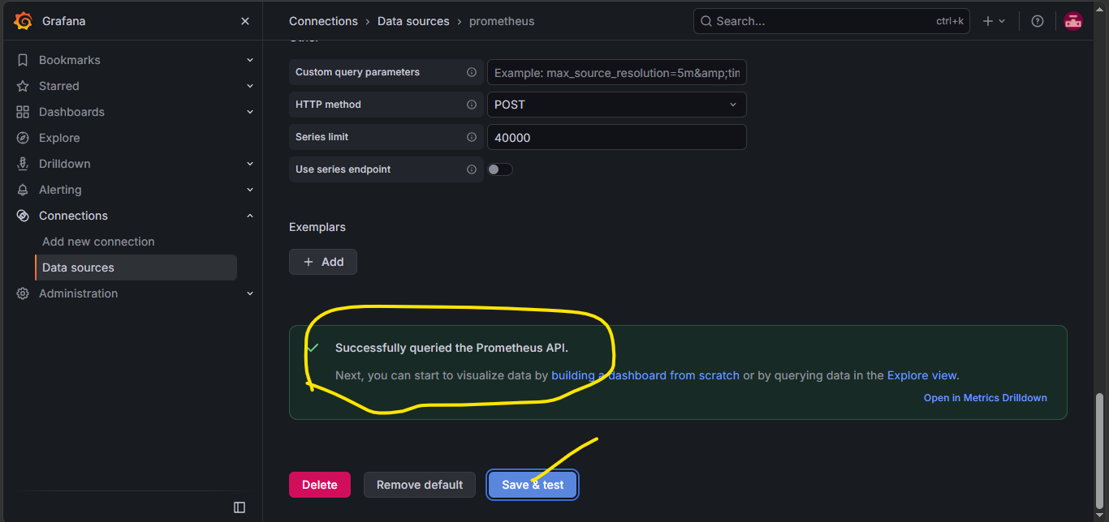

Now import dashboard
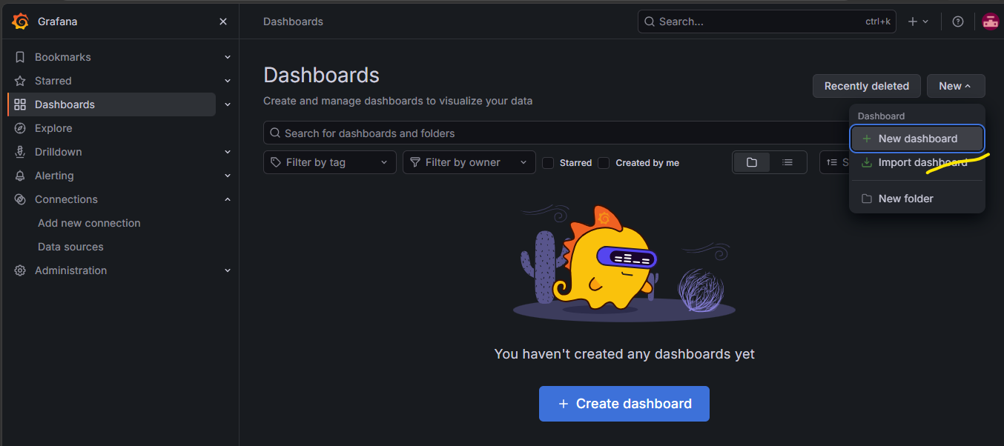

Give dashboard template code >laod >import
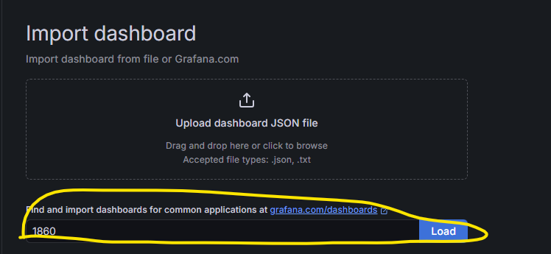
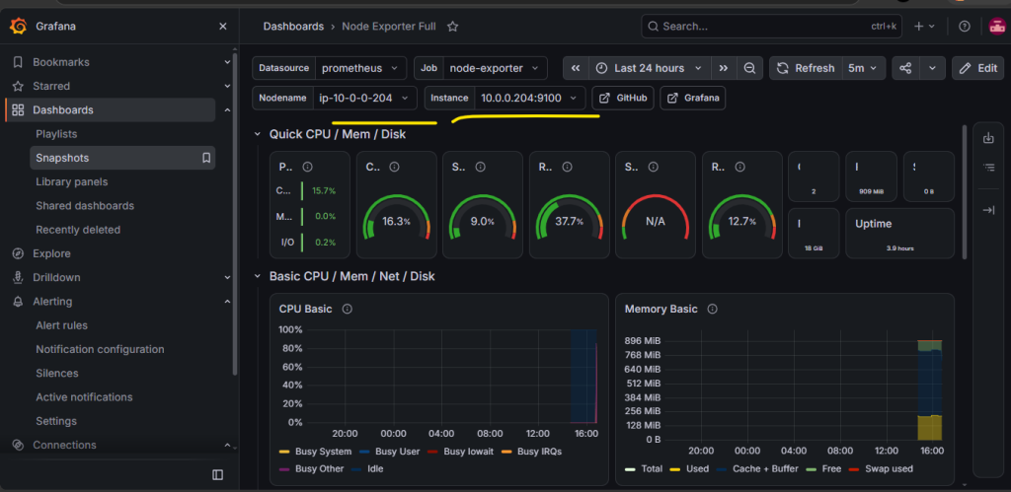
Now you can use stress in node_exporter to validate if the Prometheus fetching the log and grafana showing in the dashboard or not
sudo apt install stress -y
stress -c 4 --timeout 300

Same way we can install node_exporter in another server and update the private ip in the prometheous.yml file ( /opt/prometheus/prometheus.yml ) .

Alert manager configuration +pagerduty integration
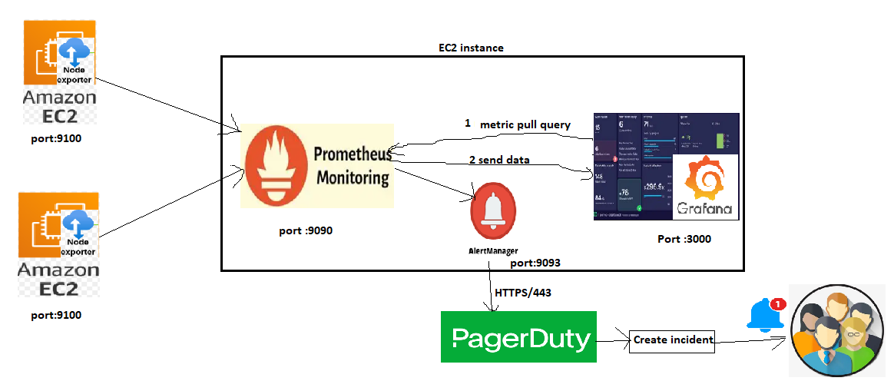

Pagerduty – based on the configuration it will trigger an incident.
Alert manager – it will collect metrics from Prometheus and sent to pagerduty

Login to pagerduty
Services -> Service Directory -> New Service
Create service (Prometheus monitoring) and store the integration key
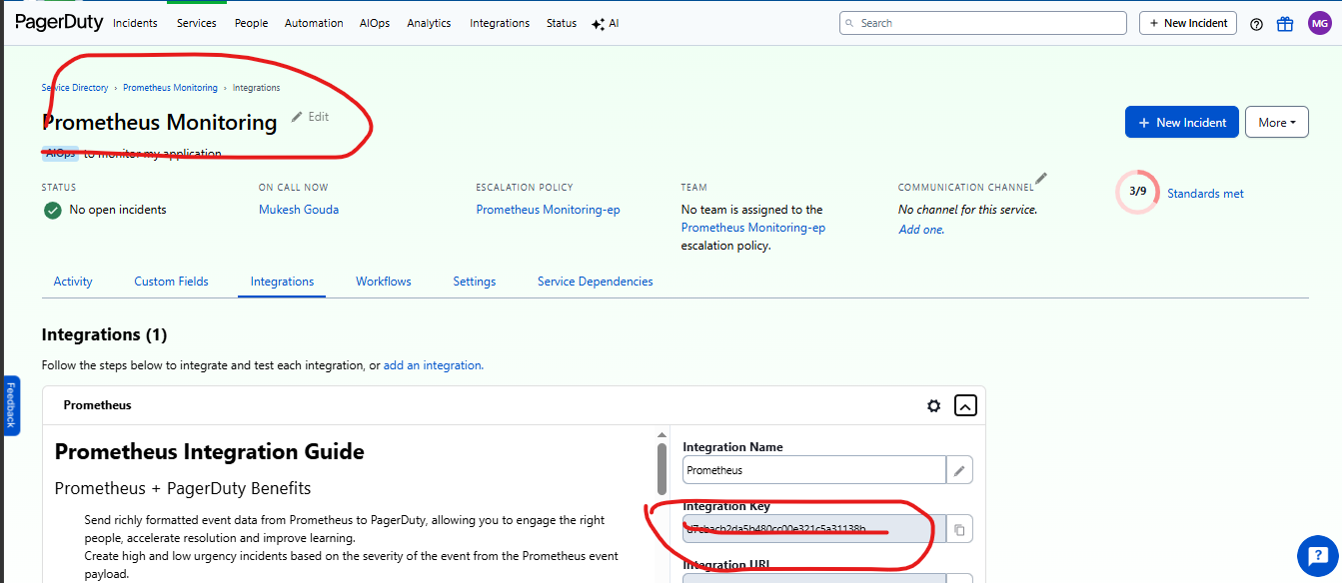

Configure alert manager in Prometheus + grafana running server(ec2-1):
cd /tmp
wget https://github.com/prometheus/alertmanager/releases/download/v0.30.1/alertmanager-0.30.1.linux-amd64.tar.gz
tar -xzf alertmanager-0.30.1.linux-amd64.tar.gz
sudo mv alertmanager-0.30.1.linux-amd64 /opt/alertmanager
/opt/alertmanager/alertmanager –version
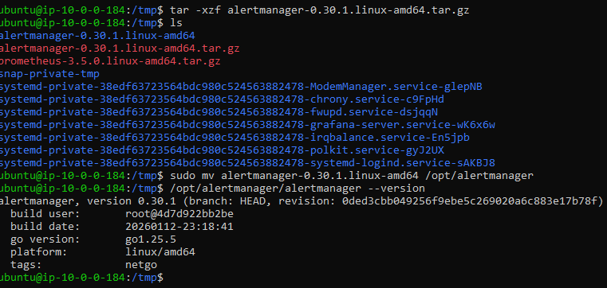
Create a non user for alert manager:
sudo useradd --no-create-home --shell /sbin/nologin alertmanager
sudo mkdir -p /opt/alertmanager/data
sudo chown -R alertmanager:alertmanager /opt/alertmanager

Alertmanager Configuration:
sudo nano /opt/alertmanager/alertmanager.yml

global:
resolve_timeout: 5m
route:
receiver: pagerduty
receivers:
- name: pagerduty
pagerduty_configs:
- routing_key: "YOUR_PAGERDUTY_INTEGRATION_KEY"
send_resolved: true

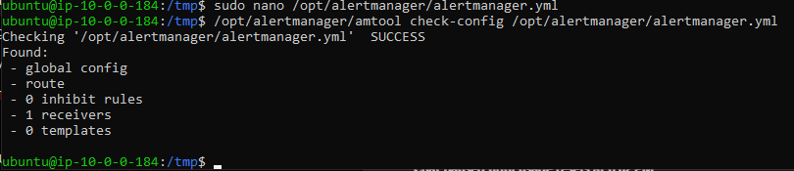

Create a service for alert manager
sudo nano /etc/systemd/system/alertmanager.service

[Unit]
Description=Alertmanager
After=network.target
[Service]
User=alertmanager
Group=alertmanager
ExecStart=/opt/alertmanager/alertmanager \
--config.file=/opt/alertmanager/alertmanager.yml \
--storage.path=/opt/alertmanager/data
Restart=always
[Install]
WantedBy=multi-user.target

sudo systemctl daemon-reload
sudo systemctl enable --now alertmanager
sudo systemctl status alertmanager

Test alert manager
curl http://localhost:9093/-/healthy
or
http://<EC2-1-PUBLIC-IP>:9093
Now create a file named rules to store the alert rules
sudo mkdir -p /opt/prometheus/rules
sudo nano /opt/prometheus/rules/node_alerts.yml

groups:
- name: node_alerts
rules:
- alert: HighCPUUsage
expr: 100 - (avg by(instance) (rate(node_cpu_seconds_total{mode="idle"}[5m])) * 100) > 80
for: 2m
labels:
severity: critical
annotations:
summary: "High CPU usage detected"
description: "CPU usage on {{ $labels.instance }} is above 80% for more than 2 minutes."
Validate
/opt/prometheus/promtool check config /opt/prometheus/prometheus.yml
Prometheus Config Update

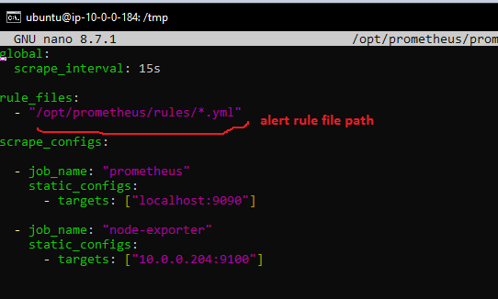
Tell Prometheus About Alertmanager:
sudo nano /opt/prometheus/prometheus.yml
global:
scrape_interval: 15s

alerting:
alertmanagers:
- static_configs:
- targets:
- "localhost:9093"

rule_files:
- "/opt/prometheus/rules/*.yml"

scrape_configs:
- job_name: "prometheus"
static_configs:
- targets: ["localhost:9090"]
- job_name: "node-exporter"
static_configs:
- targets: ["10.0.0.204:9100"]
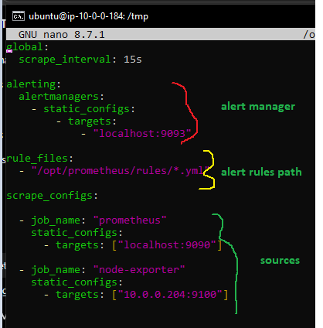

Test connection:
http://<EC2-1-PUBLIC-IP>:9090

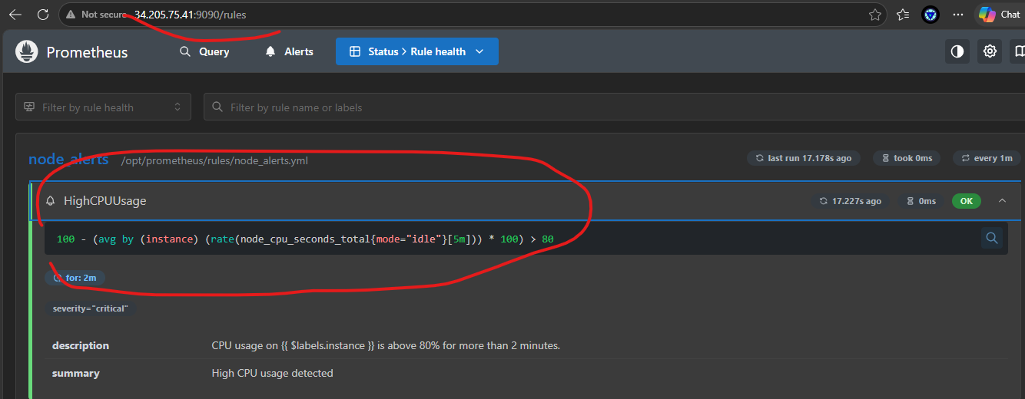

Now do the stressing using stress command in node-server(ec2-2).
And observe in Grafana ,Prometheus and Pagerduty for incident.

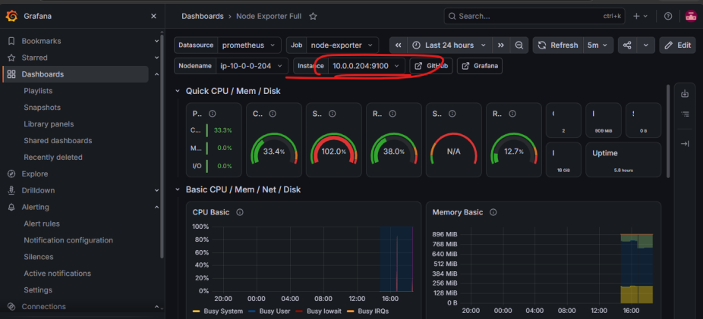

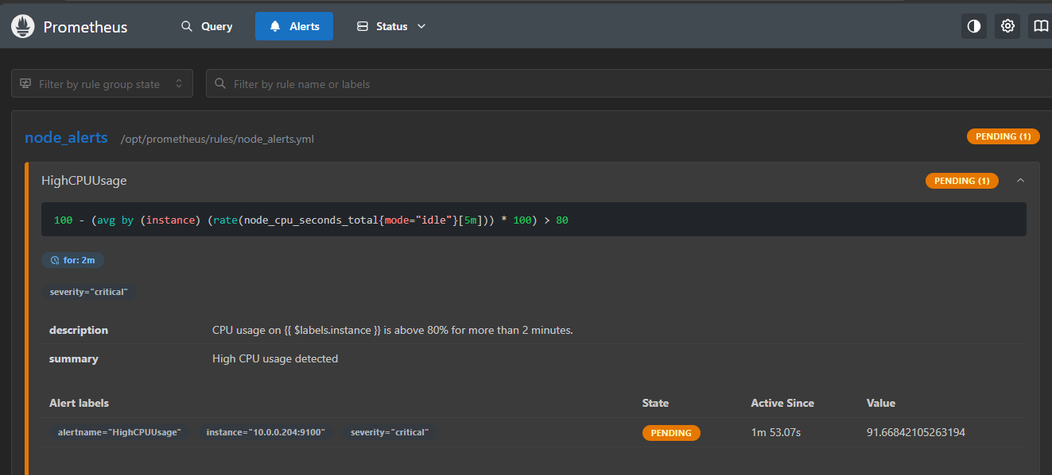
Wait till the alert in Prometheus in Firing state .
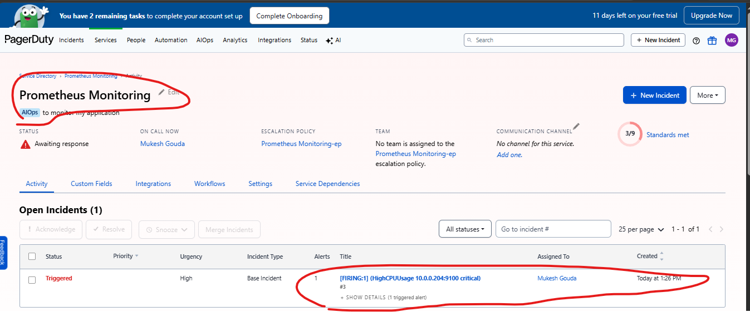

Dynamic monitoring issue :-
Dynamic Metric collection
Here we have manually added the node-server private ip to the yaml file.
But in dynamic situation like ASG it not possible to add manually and also remove once the server deleted .
To overcome this will need to implement the EC2 service discovery to auto identify the the server having node agent and tell the prometheous to scrape the data.
New EC2 launch → Node Exporter install → add tag (Monitoring=true) → Prometheus discovers it.

Mandatory :
Create Prometheus EC2 IAM role → ec2:DescribeInstances
There wont be any existing policy we need to create an inline policy and attach it to Prometheus running server .

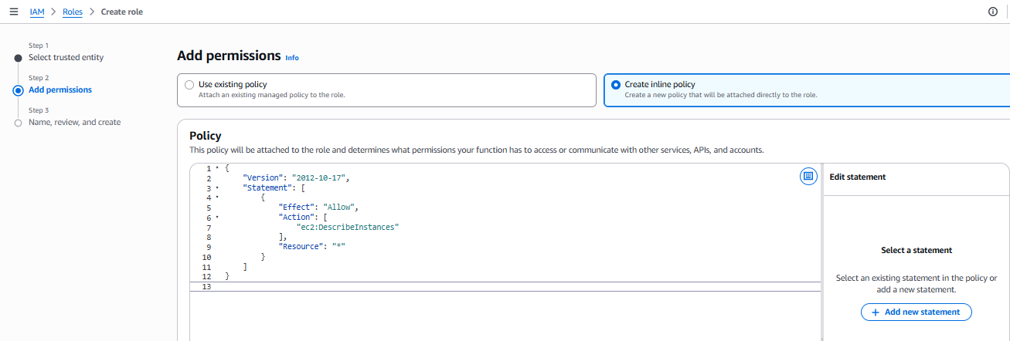

{
"Version": "2012-10-17",
"Statement": [
{
"Effect": "Allow",
"Action": [
"ec2:DescribeInstances"
],
"Resource": "*"
}
]
}

When a new server created give naming tag
1 tag ( Name:node-server )
2. open SG port :9100
3. configure node_exporter and make sure its running

